**SmartLease: A Tenant-centric Modern Approach to Apartment Rental Management System**

A Project Presented to the

Faculty of the Electrical and Allied Department Technological University of the Philippines Taguig Campus Taguig City

In Partial Fulfillment of the Requirements for the Subject

**System Analysis and Design**

Submitted by:

Casay, Dwayne A.

Cruz, Hanna Clerdee E.

Ilagan, Sachzie Sofia P.

Vila, Lord Cedric O.

GROUP 1

BSIT-NS-2A

Submitted to:

**Prof. Joan C. Mag-isa**

**TABLE OF CONTENTS**

CHAPTER 1 3

1.1 Introduction 3

1.2 Background of the Study 4

1.3 Statement of the Problem 5

1.4 Objectives of the Study 6

1.4.1 General Objective 6

1.4.2 Specific Objectives 6

1.5 Significance of the Study 7

1.6 Scope and Delimitation 9

1.6.1 Scope 9

1.6.2 Delimitations 10

CHAPTER 2 12

2.1 Foreign Literature 12

2.2 Foreign Studies 15

2.3 Local Literature 18

2.4 Local Studies 21

2.5 IPO Diagram 24

2.6 Definition of Terms 26

CHAPTER 3 27

3.1 Research Method 27

3.2 Respondents 28

3.3 Research Instrument 28

3.3.1 Interviews 29

3.4 Design Procedure 30

3.4.1 Program Flowchart 30

3.4.2 System Flowchart 31

3.4.3 Context Flow Diagram 35

3.4.4 Data Flow Diagram 36

b3.4.4.1 Data Flow Diagram Level 0 36

3.4.4.2 Data Flow Diagram Level 1 36

3.4.4.3 Data Flow Diagram Level 2 37

3.4.5 Entity Relationship Diagram 38

3.4.6 Use Case Diagram 39

3.4.7 Gantt Chart 42

# CHAPTER 1

**THE PROBLEM AND ITS BACKGROUND**

## 1.1 Introduction

The leasing process for apartments is prone to be tough and time consuming for both the tenants and the property managers. Property managers tend to encounter difficulties in maintaining records of various lease agreements, rental payments, and repair requests manually or with old methods, and delays and errors are more likely to occur. The absence of a structured interface of communication with the tenants tends to be complicated for them. These inefficiencies result in dissatisfaction for both parties, opening a door for a requirement of a modern method towards apartment leasing. The real estate rental market within the past years has seen large-scale transition into digital solutions based on the increased reliance on technology to simplify routine activities.

As urban populations rise and demand for rental apartments boosts, building managers are driven to implement procedures that respond to the evolving expectations of renters. Tenants today leans on an open and simple procedures that provide users with easy access to apartment availabilities, lease information, and payment options. This rise of modernization goes along the essential to develop a system in accordance with the needs that serves the Tenants.

The usage of the advantage of new technologies such as cloud-based data management, aims the system to be the bridge between tenants and property managers. It will allow property managers to effectively manage administrative work while catering the tenants to do their leasing activities with ease. The objective is to show how such innovations can improve rental experiences, enhance efficiency, and develop a coordinated relationship between tenants and property managers.

## 1.2 Background of the Study

The rental housing industry is at the center of urban life, yet it often goes along with inefficient, old methods. Paper records, site applications, and traditional forms of payment put burdens on both tenants and property managers. These are reasons why there are slowdowns, miscommunications, and absence of clarity, ultimately unseemly from the rental process.

With technological advancements, there is rises of potential to transform the management of apartment leasing. Tenants now anticipate faster, more transparent, and easily available solutions, with property managers seeking for tools to maximize operational efficiency. While digital platforms stand, several of them lack a fully unified and tenant-focused approach that addresses current needs. This study is based on the need for innovation and presents a system that simplifies leasing, enhances communication, and offers an easy experience to all.

Through resolution of these common issues, the suggested tenant-driven system aims to close the door between traditional practice and the shifting needs of the rental market and create a new standard for apartment leasing methods.

## 1.3 Statement of the Problem

1.3.1 Main Problem

What are the key inefficiencies and lack of tenant-centricity in the apartment leasing process that led to significant miscommunication, delays, and dissatisfaction among both tenants and property managers?

To better understand the challenges inherent in the apartment leasing process, this study seeks to address the following research questions:

1. How does inefficient communication between property managers and tenants contribute to delays and misunderstandings in the leasing process?
2. What specific errors and inefficiencies arise from manual record management practices in tenant record-keeping and lease agreements?
3. In what ways does the absence of integrated payment systems affect rent collection processes and payment tracking for both tenants and property managers?
4. How does limited transparency regarding lease agreements, maintenance requests, and payment statuses impact tenant satisfaction and trust in property management?
5. What are the shortcomings of existing digital solutions in meeting the essential needs of tenants and property managers, particularly concerning real-time updates and comprehensive management features?

By exploring these questions, this study aims to identify key areas for improvement within the apartment leasing process, ultimately leading to the development of a more efficient, transparent, and user-friendly system that enhances the overall experience for all stakeholders involved.

## 1.4 Objectives of the Study

## 1.4.1 General Objective

To develop a tenant-centric apartment system that streamlines the leasing process, enhances communication between property managers and tenants, and integrates essential features for efficient lease management, payment processing, and maintenance tracking.

## **1.4.2 Specific Objectives**

* Analyze the inefficiencies in traditional apartment leasing methods: This objective aims to identify the key areas where manual procedures and paper-based agreements contribute to delays and errors, impacting both tenant satisfaction and property management efficiency.
* Evaluate the impact of communication gaps: This objective seeks to assess how the lack of streamlined communication channels between property managers and tenants leads to misunderstandings and delays, ultimately affecting the leasing experience.
* Explore the effect modes in payment collection: This aim is based on comprehending how current payment systems affects tenant satisfaction and operational efficiency for property managers.
* Explore the advantage of real-time notification and updates: This aims to know how the integration of real-time communication functions can improve transparency and accountability in the leasing process, nurturing trust between tenants and property managers.
* Determine key characteristics for a tenant-centric digital platform: This goal is aimed at knowing what features need to be in the digital lease management solution to effectively provide the necessity of tenants along optimizing operation efficiencies for property managers.
* Review existing digital solutions available in the market: This goal seeks to evaluate current digital platforms in accordance with their performance in offering joined features that allow both tenant management and property management activities.

Through meeting these objectives, this study hopes to contribute towards building an innovative tenant-focused system that simplifies the apartment leasing process, better the user experiences, and address the changing needs of the rental market.

## 1.5 Significance of the Study

This study is essential for several populations of individuals, each who will benefit in specific ways. By improving the apartment leasing process, this study can greatly influence property managers, tenants, developers, and students in the field.

Property Managers. This study offers a convenient way of handling leases, payments, and maintenance requests without the hassle of manual labor. It saves time, reduces errors, and ensures smooth operations. Enhances communication with tenants means reduced in miscommunications and quicker response to problems, improving the quality of apartment management. Along with the ability in keeping tenants satisfied and turnover low.

Tenants. The Tenants will gain much from this study as it facilitates to make their rental process easier. By having access to details such as lease information, payment history, and maintenance request status, tenants can resolve their needs brief and fast. They can monitor their payments, get reminders, and send messages to property managers, avoiding delays or miscommunications. Overall, their renting process will be transparent and convenient for them to be satisfied.

Developers and Technology Providers. This study is a great example for developing effective, easy-to-use systems in property management. It shows how new technologies can address common problems in apartment leasing by combining capabilities such as cloud-based data storage, secure payment mechanisms, and real-time notifications. It informs technology providers on how to best to design systems to meet the needs of both property managers and Tenants.

Future Researchers. This study contributes to real estate management research, specifically on how technology can enhance rent processes. This enables the way to comprehend how technology can make property management smoother and how tenant expectations are evolving in the era of digitalization. The study can also motivate future research on enhancing property management systems and tenant satisfaction through technology.

Real Estate Industry. The real estate industry can benefit from this study it demonstrates how embracing contemporary technology can enhance the management of properties and renting them out. It may encourage property management firms to implement similar systems, which will result in faster processes, effective communication, and enhanced efficiency in the rental sector.

Urban Development Authorities. With increasing city populations and the need for rental accommodations, urban development authorities can utilize the results of this study to know what tenants and property managers require. By facilitating the application of these new systems, they can contribute to better housing management, ensuring rental procedures are more efficient and well-organized.

## 1.6 Scope and Delimitation

## 1.6.1 Scope

This study is concerned with designing a tenant-oriented apartment leasing system to facilitate the process of leasing an apartment and improving communication between the tenants and the property managers. The scope is on:

* System Architecture and Development: The study will include designing and developing a cloud-based solution that combines lease management, payments processing, and maintenance request monitoring. The platform will allow for administrative tasks automation by property managers, and leasing activities will be manageable by the tenants using a simple interface.
* Key Features and Functionalities: The system will have features like a tenant portal to manage lease contracts, request maintenance, get updates, and track rental payments (not automated). Property managers will be able to access features like listing units, managing tenant files, scheduling maintenance, and report generation for operational insights.
* Communication and Notification System: The site will have a messaging system and automatic reminders for lease renewal, maintenance status, and other essential notifications.
* Contract Management: The lease will indicate essential terms and duties for landlords and tenants, which will be transparent and compliant with law. It will include requirement for pre-termination terms, security deposits, insurance needs, association fees, late payment fees, and maintenance duties. The contract will also lay down terms for solving disputes to provide fair treatment of disputes.
* Security & Data Privacy: The study will ensure that the platform follows the best practices in cybersecurity measures such as data encryption and safe authentication procedures. It will review how these security features affect the trust of users and system dependability.
* Analytics & Reports: The system provides landlords dashboards to inspect occupancy levels, payment patterns, maintenance records, and tenants' reviews.
* Scalability and System Adaptability: The study will evaluate the capability of the system to scale to several properties, varying property sizes, and further additions like reporting facilities and advanced document verification features.
* User Roles and Access Control: The website will establish varied levels of access for users such as tenants and property managers. Every role will possess varied levels of permissions for data security and effective workflow handling.
* Evaluation: The study will include an evaluation of the system's effectiveness in enhancing the apartment leasing experience and user satisfaction. This evaluation will focus on the usability, functionality, and efficiency of the system in addressing the issues identified in traditional leasing methods.

## Delimitations

* Geographic Limitation: The scope of this study does not extend to specific geographical locations or markets. The system's applicability may vary depending on the region, legal requirements, and market conditions. The study does not account for region-specific regulations or the impact of location on tenant preferences.
* Payment Processing: While the system tracks rent and utility payments, it does not include an automated payment gateway. Payments are recorded manually and can be made either physically (cash) or online.
* Limited Technological Scope: While the study will focus on cloud-based systems, it does not go any deeper to show how emerging technologies like AI or machine learning will be incorporated into predictive analytics or automated decision-making and does not have a mobile application. The system basically works on basic functionalities and has no more complex technological advancements.
* Stakeholder Participation: The study will primarily engage property managers and tenants as the primary stakeholders. Developers, technology vendors, and city authorities will be indirectly regarded as beneficiaries, but their direct participation in the research will be minimal.

# CHAPTER 2

**REVIEW OF RELATED LITERATURE AND STUDIES**

This chapter explores relevant studies, papers, and journals that support the study. It presents both foreign and domestic literature and studies, as well as an IPO Diagram to present the framework and a section explaining key terms.

## 2.1 Foreign Literature

In the changing paradigm of property management, online platforms have reconfigured the rental housing dynamics, offering new possibilities and challenges to both tenants and landlords. Fields and Rogers (2021) analyzed how digital informalization of rental housing platforms has greatly affected rental contracts, security of tenants, and risk handling. Their research established that although these websites offered greater convenience in accessing housing opportunities, they also generated cases of insecurity among tenants because of the absence of regulatory frameworks and inadequate transparency in lease contracts. To which is very much relevant to the present study, **SmartLease: A Tenant-Centric Modern Approach to Apartment Rental Management System**, as it seeks to counter such issue through a more open and safer means of bridging tenants and landlords into credible, well-specified rental contracts. The study also emphasizes the needs of automating rental transactions to minimize human intervention and the risk of of concealed or manipulated contract terms, which SmartLease aims to incorporate into its system.

The research carried out by Chen, Ye, and Lin (2019) fully supports this statement through the presentation of blockchain technology as a solution to urge transparency and security problems in rent systems. The authors demonstrated how the use of Ethereum smart contracts in rents completely removes middlemen, allowing automated and legally binding deals. Moreover, employing IPFS (InterPlanetary File System) allows safe and non-editable storage of data, reducing the possibility of manipulation and conflict. This directly caters to the security concerns raised by Fields and Rogers (2021) and is in accordance with the aims of this study in developing a secure environment for leasing transactions. With the addition of the same digital infrastructure, SmartLease can have enforceable and transparent lease contracts without third-party interference, restricting disputes and ensuring harmonious landlord-tenant relationships.

Yet another real challenge in rental management, despite technological advancement, is tenant compliance, especially in terms of late or missed rental payments. This challenge was also presented by Adebisi (2024) in his Nigerian study where tenant attributes (financial strength, creditworthiness, and demographic data) were analyzed against lease performance metrics. The research suggests that financially secure tenants with strong payment history have been more likely to live by the letter of lease agreements and tenants with financial stress more likely to be late or defaulting on rents. This finding further backs up Chen et al. (2019) who argued that contracts that are both transparent and autonomous can lower disputes because tenants with clear financial history are likely to pay rent reliably. SmartLease seeks to incorporate a feature that tracks a tenant's history of payments and automates regular reminders for rent. This not only ensures that landlords stay in good flow for income, but it too also encourages responsibility from tenants.

Salas and Nothaft (2022) also observed for the positive momentum of several other areas of property management technology capabilities, following an improvement for payments compliance and lease management showing that property management technology capabilities can help improve rent operations. Their research showed short-term rental marketplaces which automated administrative tasks allowed property managers to concentrate on pleasing tenants rather than maintaining units. Automated lease management function which centralizes tenant requests, maintenance issues, and payment monitoring to ease operation burdens and improve the efficiency of property management.

Socienta (n.d.) further emphasized that as in other industries, tenants will have high expectations of property management systems to meet their needs as they move deeper into the digital age. The report identified that tenants expect fast and transparent lease agreement processes, tracking payment, and communication with landlord. The work of Salas and Nothaft (2022) illustrates this well, finding that today’s solution for property management systems incorporating automation and a digitized nature would be likely to produce a greater degree of tenant satisfaction and operating efficiency; therefore, this should come as no surprise. This consensus is founded on what SmartLease trades as for smarter, tenant-friendly rental platform creation through communication, automatic, processing, and financial statement between tenants and property managers.

## 2.2 Foreign Studies

There exists a major demand for a useful, renter-based flat rent system, making owners integrate computer technology to streamline leases. Shriram, Nandhakumar, Revathy, and Kavitha (2019) reiterated that the interconnection of apartment management systems has a critical position in improving overall rental efficiency through automated tenant management, maintenance requests, and lease contracts from it. The study showed typical apartment management often led to problems like slow maintenance response times. Landlord-tenant disputes, in addition to payment mistakes, also arose. This is in keeping, and aligning also, with the chief goal of the present study, SmartLease: A Tenant-Centric Modern Approach to Apartment Rental Management System, to rationalize fully apartment rental processes via an integrated system which reduces functional inefficiencies whilst maximizing tenant satisfaction. Through the incorporation of equivalent automation capabilities according to their research, SmartLease can provide to tenants and property managers equally a smooth and highly effective rental management experience.

In the same vein, Hargreaves (2023) explored the future of property management systems, emphasizing the evolving role of technology-based platforms in streamlining rental transactions. According to the research, property management in the future will depend heavily on automation, communication based on AI, and insights backed up by data to remove errors and reduce human interference. This is consistent in agreement with Shriram et al. 's (2019) argument that modern apartment management systems need to evolve from traditional manual operations to become fully automated. The research highlighted which caused lower tenant satisfaction and high operational inefficiencies in property managers who cannot catch up on digital options. In response, SmartLease seeks to fuse a digital dashboard able to handle maintenance requests, monitor lease agreements, automate payment reminders, and open communication channels between landlords and tenants — filling in the gaps highlighted in both studies.

However, against the positive benefit of handling digital property, Texas (2025) enumerated emerging trends and challenges impacting the handling of various properties in urban cities more than any other factor. The study identified that handling multiple rental properties in the absence of an integrated system typically results in communication problems, delayed payment of rent, and poor maintenance tracking. Additionally, the research has shown that tenant anticipation of prompt and fast service has greatly increased over the recent years, thus compelling property managers to modernize. This is an outright echo of the assertions made by Hargreaves (2023) that the solutions for property management in the future will be required to have tenant-friendly interfaces as well as automated workflows. This is in the vision of SmartLease since the platform works to provide an innovative, tenant-centric system that can manage different property management challenges, improving communication, automated rent payment, and hassle-free maintenance management.

Adding more proof of the necessity for better property management systems, Parcel Pending (2024) provided data on multifamily housing trends for 2025, emphasizing the increasing importance of hassle-free and automated rental processes. According to their report, property managers will be increasingly pressured to make communication, payment, and service requests easier to align with evolving tenant expectations. The research also identified that the tenants are more and more gravitating towards the properties that offer online payment services, immediate processing of maintenance requests, and 24/7 customer care. This is in agreement with the argument presented by Texas (2025) and Hargreaves (2023) that the future of property management will be highly reliant on technology-based platforms. SmartLease aims to fulfill this requirement by providing tenants with a digital rent platform that supports automated lease payments, timely maintenance notifications, and simple tenant-landlord communication, minimizing the burden of manual processes while guaranteeing tenant satisfaction.

Similarly, Buildium (2024) provided rental market predictions for property managers in 2025, which showed that tenant expectations of faster, simpler, and more transparent rental experiences are gaining dominance. According to their analysis, tenants now anticipate an all-encompassing platform where they can monitor their rent, make requests for maintenance, communicate with property managers, and review their lease agreement. The study also noted that property managers adopting technology-driven solutions enjoy better tenant retention and lower operational costs. This directly affirms the results presented by Parcel Pending (2024), who emphasized the need to automate leasing processes to enhance tenant experiences. To cover these growing requirements, SmartLease is designed to incorporate these significant features such that tenants are able to easily manage their rental activities and lower tensions and delays in property management activities.

Through the merging of the findings presented by these studies, it is obvious that the path of the future of apartment rental management is via the unification of tenant-oriented and technology-driven solutions. Shriram et al. (2019) laid the groundwork by emphasizing the importance of apartment management systems in preventing operational inefficiencies, while Hargreaves (2023) built on this by emphasizing the necessity of digitalization within next-generation property management strategies. Texas (2025) reaffirmed this notion by depicting the intricacies of managing multiple rental properties, stressing the need for an all-around and automated platform to oversee communication, payment, and maintenance requests. Parcel Pending (2024) and Buildium (2024) substantiated these claims by projecting that tenant expectations will only continue to rise to necessitate quicker, more transparent, and more streamlined rental management.

One of the most critical concerns in today's rental management is that of delayed rents and arrear payments, particularly in the midst of global economic uncertainty. The Urban Institute (2021) studied rental arrears during the pandemic and estimated total unpaid back rent to be between $8.4 billion and $52.6 billion. The report highlighted that many tenants struggle with payment delays due to financial instability, causing disruptions for landlords and property managers. This concern ties directly to Adebisi’s (2024) research, which found that tenant financial stability is a key determinant of lease compliance. SmartLease will address this demand by incorporating automated late payment reminders, flexible payment schedules, and budget tracking features, enabling tenants to remain up to date with what they are paying and helping landlords keep current with cash flows.

## 2.3 Local Literature

Computerization of housing rental management systems is now the inevitable solution for the problems landlords, property managers, and lessees have been facing. With increasing need for real-time transactions, automating processes, and coordinating work, researchers tried to study various ways in improving rental management processes.

Magno et al. (2024) demonstrated an apartment rental management system for real-time transaction processing and task organization. Their study highlighted the importance of an online-based, central digital platform to facilitate rent collection automation, lease management, and communication with tenants. The research emphasized that real-time monitoring of rental transactions minimizes payment lags, and an organized task system enables property managers to process maintenance requests and tenant complaints effectively. These results validate the aims of SmartLease: A Tenant-Centric Modern Approach to Apartment Rental Management System, which is to integrate real-time transaction functionality with simple-to-use interface that increases tenant satisfaction and simplifies property management operations. This is attested by a Philippine Journal of Public Administration (2023) study exploring the property management methods and cost approaches in Calamba City.

The study found that manual processes used in renting management have a tendency to cost more in administrative costs, resulting in inefficient maintenance schedules, as well as unhappy tenants. The study underscored the need to embrace digital solutions with the potential of reducing operational costs but increasing the efficiency of services. This assertion is also that of Magno et al. (2024), who argued that an automatic organization tool for rental tasks reduces property management inefficiencies by a very substantial amount. In response to such observations, SmartLease aims to minimize administrative costs by the integration of automated features such as lease agreement tracking, electronic rent collection, and an interactive tenant support system to ensure a seamless and cost-effective process of renting. Aside from supporting the demands for a modernized method of management, STI College General Santos City (2022) proposed a Residential Management System in a capstone project, its intention being improvement in digital record-keeping and optimization of communication processes among landlords and tenants.

In the research, common problems encountered by traditional property management were identified: prolonged response time for maintenance activities, difficulty in tracking rental collection, and absence of maximum tenant record maintenance. The findings are to a great extent supported by Magno et al. (2024) and the Philippine Journal of Public Administration (2023), which reported the advantages of automation in reducing rental management hassles. SmartLease seeks to address these problems by offering a cloud-based tenant database, rent reminders automatically, and maintenance request tracking, among other features, to both landlords and tenants. In addition, a 2021 review of apartment management systems (Academia.edu) compared apartment management platforms and their features.

The review highlighted the significance of automation in rent collection, lease processing, and tenant data management. It identified user-friendly interfaces, mobile access, and real-time financial tracking as essential features for effective rental management. These findings align with the views of STI College (2022), Magno et al. (2024), and the Philippine Journal of Public Administration (2023), all of whom were calling for the necessity to automate landlord-tenant interaction. The findings of this research also support SmartLease's approach of combining a mobile-enabled, cloud-based platform that streamlines rental management through real-time money tracking and automated communication with tenants. Lastly, the Apartment Rental Management System Documentation (2020) by Scribd gave a technical overview of an apartment rental system, including its architecture, features, and implementation problems.

The documentation pointed out key system components such as tenant registration modules, payment gateway modules, and complaint management systems. The study emphasized the requirement for an integrated dashboard that provides landlords with an overview of rental transactions, pending maintenance requests, and lease status updates. These technical aspects concur with previous studies (Academia.edu, 2021; STI College, 2022; Magno et al., 2024), which suggest automated tracking, real-time monitoring, and efficient tenant-landlord communication. According to this, SmartLease is planning for an integrated intelligent dashboard with analytical features where the landlords are able to monitor efficiently the performance of the properties, monitor issues complained by the tenants, and efficiently manage rental transactions.

## 2.4 Local Studies

The continuous advancements in digital technology have revolutionized the management of rental properties, improving efficiency, automation, and tenant satisfaction. There have been numerous studies on how web-based rental management systems have evolved, tenant retention factors, and the effect of automation on lease management. These studies are significant contributions which adhere to the aims of SmartLease: A Tenant-Focused Contemporary Way to Apartment Renting Management System, which seeks to improve the rental process through addressing transaction inefficiencies, better communication, and streamlining tenant-landlord communication.

Leona, Ramos, and Dela Cruz (2023) designed AppStay, an online room, dormitory, and apartment booking system that facilitates easier leasing through online booking, payment facilities, and room availability in real-time. The study was directed towards the increasing demand for digital platforms that enhance convenience for both landlords and tenants by doing away with physical bookings and enhancing business efficiency. This is in tandem with SmartLease's dream of bringing into existence an automated leasing process that simplifies the booking of an apartment, managing contracts, and monitoring payments. However, while AppStay largely focused on short-term leasing, SmartLease uses the same approach to apply to long-term apartment leasing, ensuring higher compliance with leases as well as interaction between tenants and property managers. In response to the need to improve tenant experience, Salazar (2024) conducted research on the determinants of tenant retention in commercial leasing buildings in Cebu City, Philippines.

Results were that accessibility to property, ease of payment, responsiveness of maintenance, and flexibility in lease directly influence tenants' satisfaction and lease renewal. This study supports Leona et al. (2023)'s finding that targeted the digitalized tenant experience in improving property management. SmartLease aims to tackle these significant factors by integrating features such as automatic rent payment reminders, a maintenance request tracking system, and a secure communication portal between the landlord and tenant. By integrating these significant features, SmartLease not only ensures an efficient rental process but also long-term tenant satisfaction and retention. Another study that confirmed the importance of automating rental management is that of Ybañez et al. (2022), which introduced a Rental Management System for simplifying lease agreements and efficiently tracking tenant records.

Their study demonstrated how an integrated digital system can reduce errors, increase transparency in finance, and improve the management of tenants. The findings of this study agree with Salazar (2024), which emphasized that efficient tenant record-keeping and automated lease tracking are critical to tenant satisfaction and lease performance. SmartLease encapsulates the same concept by giving a real-time tenant database for landlords to track lease status, rental payments, and maintenance requests without the necessity of traditional, paper-based mechanisms. Continuing to promote the usefulness of digital applications in real estate, Villasin and Encarnacion (2024) conducted a study of the perceptions of realtors toward processing property data, highlighting the necessity of web-based real estate management systems.

They learned through their study that real estate agents want automatic systems to assist in property listing, tenant screening, and lease preparation. This was supported by the study of Ybañez et al. (2022), which addressed the advantages of digital rental management systems. The study advocates for SmartLease's purpose of providing a user-friendly property management interface that benefits tenants, landlords, and real estate agents by offering streamlined lease documentation, real-time updates, and enhanced property monitoring. Lastly, Magno, Pelayo, and Soberano (2024) considered the application of an Apartment Rental Management System for Real-Time Transaction and Task Organization, emphasizing automation as a strategy to improve lease agreements, rent payment, and property upkeep.

Their study concluded on the point that computerized real-time information reduces transaction time, prevents miscommunication between the landlord and tenant, and overall rental property performance is improved. This is directly in line with Villasin and Encarnacion's (2024) findings, where they also urged the application of web-based solutions in rental management. SmartLease is built upon such research through the inclusion of an entire transaction and task management system that enables seamless communication, scheduled payments, and real-time monitoring of property upkeep to enable a superior rental experience.

## 2.5 IPO Diagram

|  |  |  |
| --- | --- | --- |
| INPUT | PROCESS | OUTPUT |
| Users:   1. Computer Literate 2. Knowledgeable in web   Developers/Knowledge:   1. Knowledgeable in HTML and CSS 2. Can code in PHP, Java 3. Experienced in MYSQL   Software:   1. Visual Studio Code 2. XAMPP 3. MYSQL 4. Web Browsers   6.1 Chrome 103 & up  6.2 Firefox 101 & up  6.3 Edge 102 & up  Hardware:   1. Desktop/Laptop   Processor:   * Minimum: Intel Core i3 or AMD Ryzen 3 (or equivalent) * Recommended: Intel Core i5 or AMD Ryzen 5 (or equivalent)   RAM:   * Minimum: 4GB DDR4 * Recommended: 8GB DDR4 or higher   Storage:   * Minimum: 128GB SSD or HDD * Recommended: 256GB SSD or higher for better performance |  | **SmartLease: A Tenant-centric Modern Approach to Apartment Rental Management System** |

## 2.6 Definition of Terms

Apartment – A single, independent dwelling unit in a larger building, usually leased and containing basic living areas such as bedrooms, a kitchen, and a bathroom.

Housing – Living quarters, such as apartments, houses, and condominiums, that are used as residences by individuals and families.

Landlord – The owner or approved manager of a rental property who is in charge of leasing, rent collection, and property upkeep.

Lease – An official agreement between a landlord and tenant stating the terms and conditions under which a property is rented, including time period and payment terms.

Property – A physical asset like land, buildings, or houses that can be owned, leased, sold, or rented for residential or business use.

Rental – The act of leasing a property, i.e., a house or apartment, for periodic payments as outlined in a rental contract.

Smartlease – A new-age rental system that combines electronic contracts, automatic payments, and web-based property management tools to make leasing easier for landlords and tenants alike.

Tenant – An individual or organization renting a property on a lease contract.

Tenant-centric A property management approach that places the focus on tenant satisfaction with flexible lease terms, improved services, and an improved rental experience.

# CHAPTER 3

**RESEARCH METHODS AND PROCEDURES**

## 3.1 Research Method

The research methodology used to create SmartLease is founded on the agile approach. Agile, or "quick and well-coordinated in movement," is a technique that focuses on breaking down the project into smaller, manageable phases known as "sprints." The team reviews what they have accomplished after each sprint, identifies where they can do better, and adapts their plan for the next phase. This cyclical process ensures continuous progress and adaptability. Agile is best suited for SmartLease as it allows the system to change in accordance with change without disturbing the workflow in the first place. Its cyclic nature makes it easy to incorporate feedback and adapt to altering market trends. Besides its practical benefits, agile also promotes teamwork within the work environment. It allows open communication, collaboration, and trust among team members. Unlike the traditional waterfall model, where activities are performed in a predetermined sequence, agile encourages ongoing involvement and contribution by all stakeholders throughout the development process. With the application of the agile method, the SmartLease development continues to be flexible, efficient, and user focused. This approach enables the system to evolve based on real needs while maintaining high levels of functionality and usability.

## 3.2 Respondents

SmartLease seeks to enhance the leasing and renting experience using smart technology for efficient property management. The primary users of the system are landlords and tenants because they are the two key stakeholders who directly interact with the platform. The primary objective of SmartLease is to simplify the leasing process by offering a seamless platform for rental agreement management, automatic payment processing, and communication between tenants and landlords. Landlords benefit from greater efficiency, reduced administrative bother, and more effective tenant management, and tenants have a freer and less bothersome leasing experience with easy access to rental agreements, payment history, and maintenance requests. Landlords using SmartLease can create more effective relationships with tenants, leading to higher rates of retention and improved tenant satisfaction. Tenants, in turn, also gain the advantage of a more efficient and accessible rental experience, with a more streamlined and efficient leasing process for all parties.

## 3.3 Research Instrument

The researchers will use an interview as the main data collection method. The interview will be a guided conversation with the client to evaluate the functionality, applicability, and usability of the system in property management. This is done to gain insights into the client's specific needs and expectations of SmartLease. The data collected will be used to determine the most important areas for improvement prior to full implementation. In addition, this study will encompass additional analysis in light of the responses obtained.

## 3.3.1 Interviews

An interview is a research method by which data are collected from the respondent in the form of raw information about an issue under inquiry. In order to come across the requirements of the client, issues and rental management expectations, a scheduled interview was conducted. The obtained data will prove imperative in dictating how SmartLease could be customized in respect to improvements relative to the expectations of the client. A personal interview will allow for the clarification of responses and further explanation, enabling a thorough understanding of the client's perspective. The information gathered from the interview will play a key part in the refinement of the SmartLease system.

## 3.4 Design Procedure

## 3.4.1 Program Flowchart

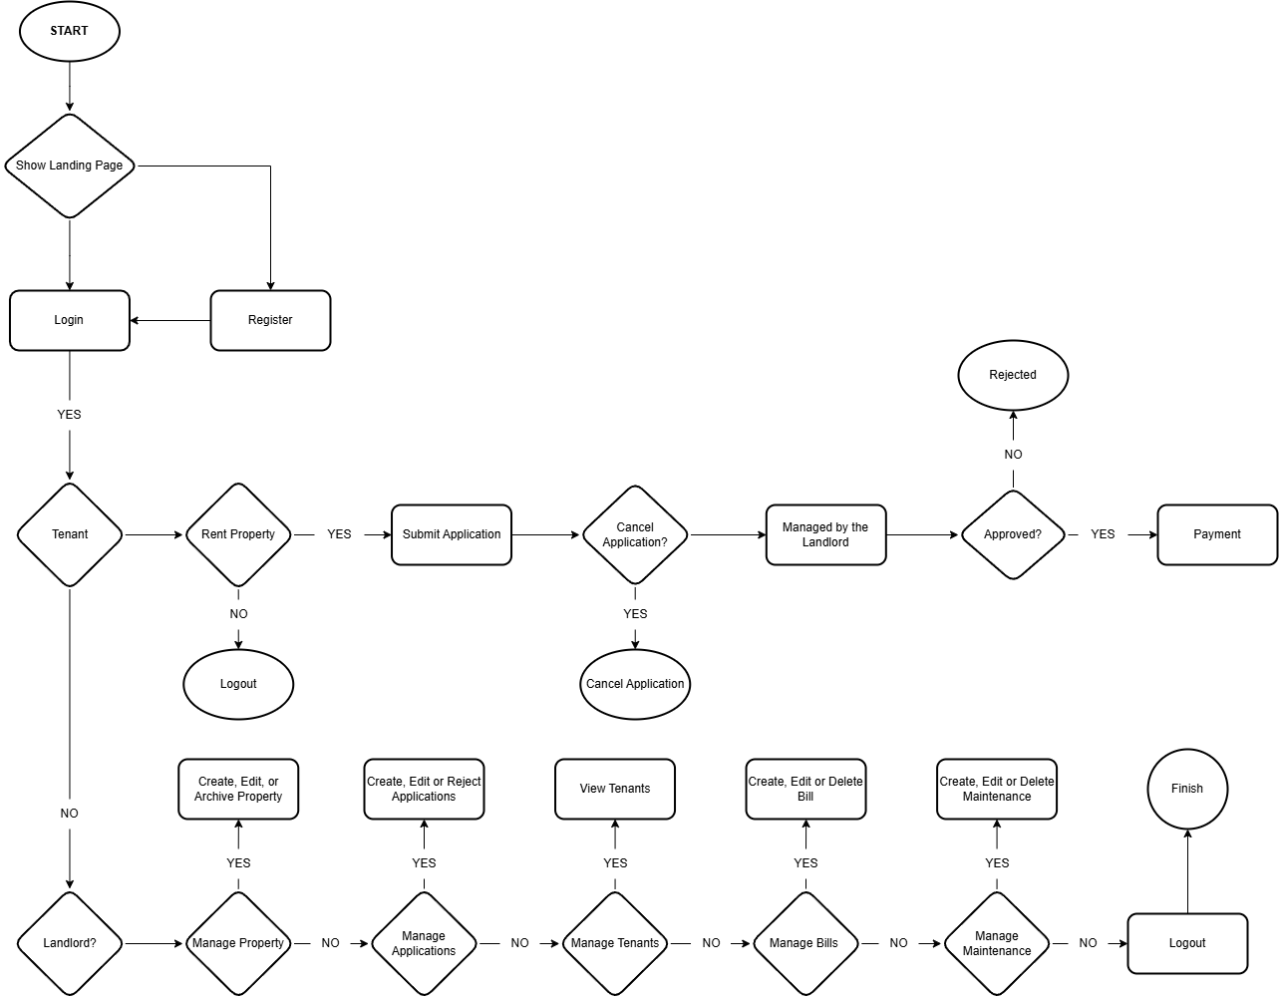

**Figure 1. Program Flowchart of Smartlease**

The flowchart illustrates the process flow of SmartLease, a Property Rental Management System, detailing steps from user interaction to the execution of the important operations. The system starts with the Landing Page, where the users can Login or Register. After logging in, the users are classified as either Tenants or Landlords. Tenants who wish to Rent a Property must Submit an Application for approval. They also have the option to Cancel the Application before it is processed. The application is then Managed by the Landlord, who decides whether to Approve or Reject it. If Approved, the tenant proceeds to Payment, completing the rental process. If Rejected, the process ends. For landlords, SmartLease offers various management functionalities. They can Manage Properties by creating, editing, or archiving listings, Manage Applications by reviewing, editing, or rejecting tenant requests, Manage Tenants by viewing tenant details, Manage Bills by creating, editing, or deleting rental invoices, and Manage Maintenance tasks for property upkeep. If the landlord does not wish to proceed with any action, they can simply Logout, ending their session. The financial module ensures that once an application is Approved, the tenant must complete the Payment process to finalize the rental. At any point, users can Logout, which marks the end of their interaction. SmartLease streamlines the property rental process, offering an efficient and structured approach to tenant applications, property management, billing, and maintenance.

## 3.4.2 System Flowchart

**Figure 2. System Flowchart of Smartlease**

Figure 2 illustrates the **login and registration process** of the **SmartLease system**, serving as the initial gateway for users to access its functionalities. Upon accessing the system, users are directed to the **Landing Page**, where they are prompted to either **log in with their credentials** or proceed with the **registration process** if they do not yet have an account. If the user **does not have an account**, they are redirected to the **Register** page. After successful **registration**, they are brought back to the **Login** page. In case of failed registration, they can try the process again. Users with existing accounts are taken directly to the Login page, where they need to input their credentials. In case of failed login, they are requested to try again. On **successful** **login**, the system identifies the role of the user as a **Landlord** or a **Tenant. Landlords** are routed to section **A**, where they can handle properties, applications, tenants, bills, and maintenance requests. **Tenants** are routed to section **B**, where they can search properties, apply for rentals, and handle rental transactions. Such a well-organized flow enables a seamless user experience whereby both **landlords and tenants** can easily access features of the system depending on their specific roles.

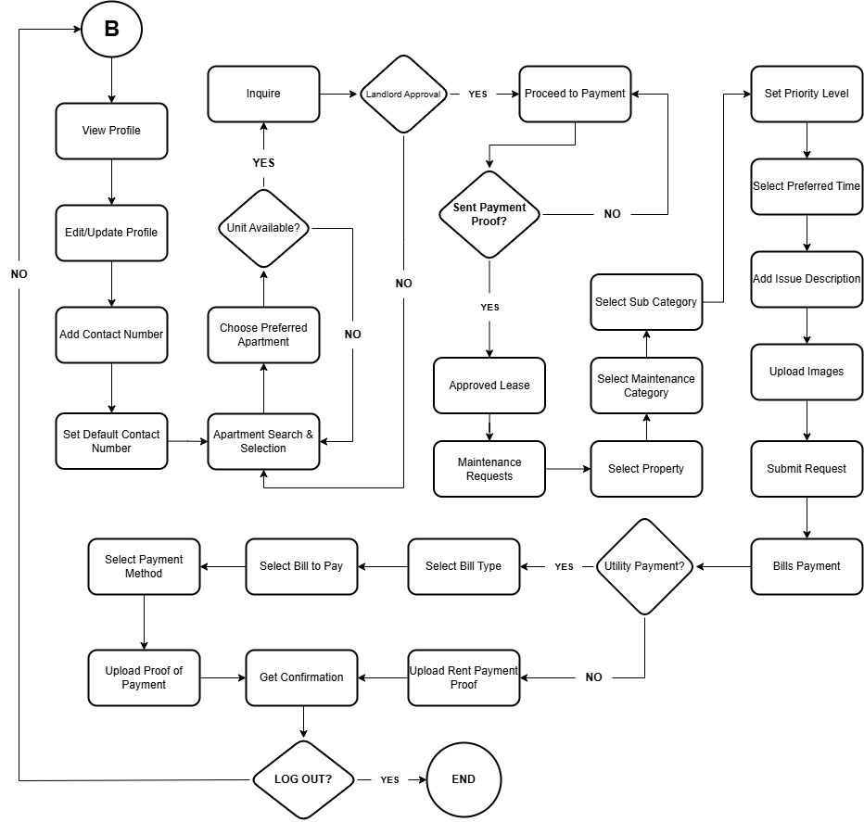

**Figure 3. System Flowchart of Tenant**

This system flowchart illustrates the process for the tenant in a rental management system. The process begins with the tenant browsing and changing their profile, such as adding and defaulting a contact number. They can search for vacant apartments and apply. In case the unit is vacant, the application is forwarded for landlord approval. Upon approval, the tenant makes the payment and submits evidence. If proof of payment is confirmed, the lease is approved, and tenants are able to request maintenance services by choosing the property, category, and issue details, then submitting their request. Also, tenants can manage bill payments by choosing the type of bill, uploading payment proof, and getting confirmation. Lastly, they can log out, closing their session.

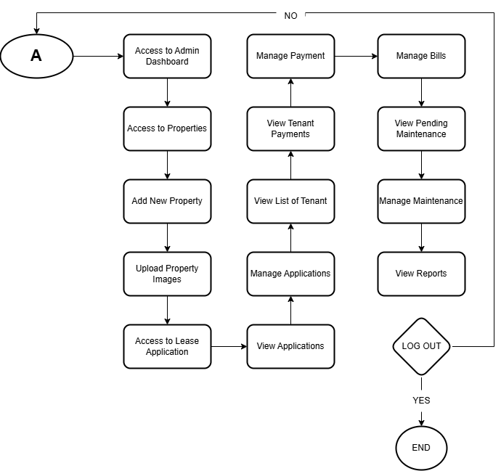**Figure 4. System Flowchart of Landlord**

This system flowchart outlines the landlord's workflow in the rental management system. The process starts with logging into the admin dashboard, where the landlord can handle properties by adding new listings, uploading photos, and processing lease applications. They can also monitor tenant applications by viewing and managing them, as well as keeping a list of tenants and monitoring their payments. The system also caters financial management, where the landlord will be able manage bills and payment. Maintenance activities are covered, and there are choices to view outstanding maintenance, manage requests, and produce reports. Lastly, the landlord can log out to close his or her session.

## 3.4.3 Context Flow Diagram

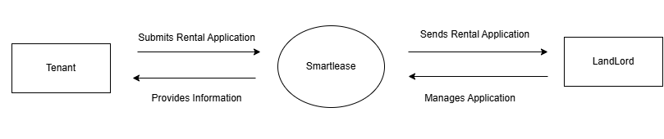

**Figure 3 Smartlease Context Flow Diagram**

The SmartLease context flow diagram depicts how tenants and landlords interact with the system. The tenants initiate by submitting a rental application to SmartLease, which accepts the application and stores related information. The system sends the information back to the tenant, such as the application status updates. Upon submission of the application, SmartLease sends it to the landlord, who can see and process it in the system. Landlords have the option of approving or rejecting applications. This structured interaction creates an efficient and transparent process with SmartLease acting as an intermediary that ensures convenient communication between landlords and renters. The process not only enables efficient handling of applications but also ensures timely updates to both the parties, and this improves the overall renting experience.

## 3.4.4 Data Flow Diagram

## b3.4.4.1 Data Flow Diagram Level 0

**Figure 4.1 Smartlease Data Flow Diagram Level 0**

The SmartLease system is designed to facilitate easy communication between tenants and landlords for a seamless and transparent renting experience. The Level 0 Data Flow Diagram (DFD) provides the overall description of the system with specifics on how tenants and landlords interact with the central SmartLease system. Tenants can apply for a lease, upload applications, and receive updates on the status of their application. Alternatively, landlords are in a position to manage applications, receive notices, and examine tenant information to aid them in their informed decisions. The system becomes the middle person that handles applications for rent, maintains records, and provides hassle-free communication among the two entities.

## 3.4.4.2 Data Flow Diagram Level 1

**Figure 4.2 Smartlease Data Flow Diagram Level 1**

The internal system processes are further categorized in the Level 1 Data Flow Diagram. The system validates the request for correctness and completeness after a tenant has applied for a lease. The application is then screened, and the system verifies the data provided. Once the application is approved, the system ensures payment proof confirmation so that the payments are processed securely. Additionally, notifications are sent to landlords and tenants, indicating the status of the lease application.

## 3.4.4.3 Data Flow Diagram Level 2

**Figure 4.3 Smartlease Data Flow Diagram Level 2**

Level 2 Data Flow Diagram presents the internal procedures of SmartLease at a more detailed level. The process begins with validating tenant requests, whereby the system checks for input data and handles invalid submissions. Once validation is done, the system fetches information on properties, pre-selecting lease options according to the preferences of the tenant. Lastly, the system displays information on leases through an interactive interface, enabling tenants to view relevant information and access available properties in an easy-to-use manner.

## 3.4.5 Entity Relationship Diagram

**Figure 5 Smartlease Entity Relationship Diagram**

The Entity Relationship Diagram of Smartlease: A Tenant-centric Modern Approach to Apartment Rental Management System is illustrates in the Figure 5.

## 3.4.6 Use Case Diagram

**Figure 6 Landlord Use Case Diagram**

Figure 6 is SmartLease Landlord's role use case diagram. The landlord can log in so they can manage their profile, view details about tenants, and list properties on the website. They can also view listed properties, accept or decline lease offers, manage tenants, and track rent status. Furthermore, landlords can take care of maintenance requests, payments, and logout after having their work completed. These functionalities offer landlords full control over their rental properties and tenant communications, making the rental process smooth.

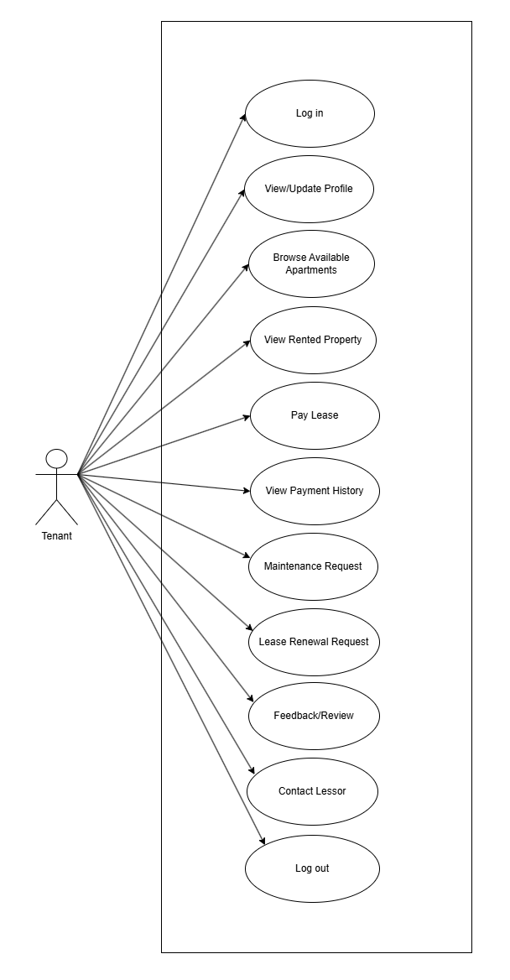

**Figure 7 Tenant Use Case Diagram**

Figure 7 shows the use case diagram of the Tenant role for SmartLease. The tenant can log in to access various functionalities including viewing and updating their profile, viewing available flats, and viewing rented flats. Besides, the tenant can pay lease, view payment history, request maintenance, and request renewal of lease. The tenant can also give feedback/reviews, contact landlord, and log out after completing the tasks. Such features enable tenants to operate their lease, payments, and landlord communication efficiently.

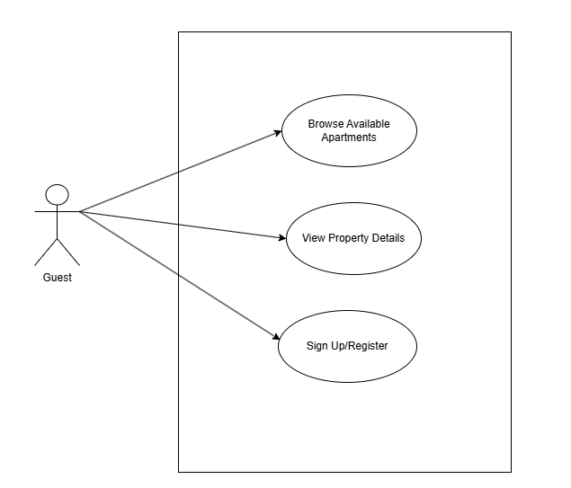

**Figure 8 Guest Use Case Diagram**

Figure 8 depicts the use case diagram of the Guest role of SmartLease. The guest user can search for available apartments and view property details without registering. If they wish to proceed with leasing a property, then they must sign up or register within the system. This enables guests to research rental possibilities prior to entering an account.

## 3.4.7 Gantt Chart

